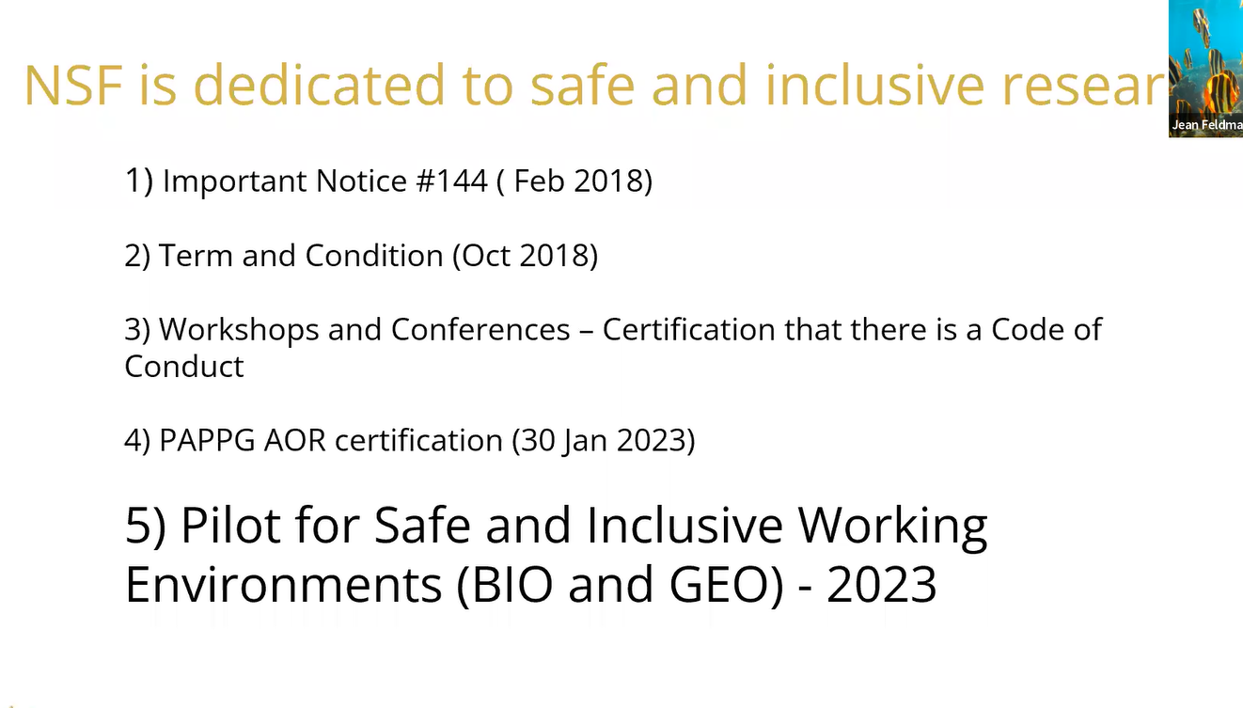
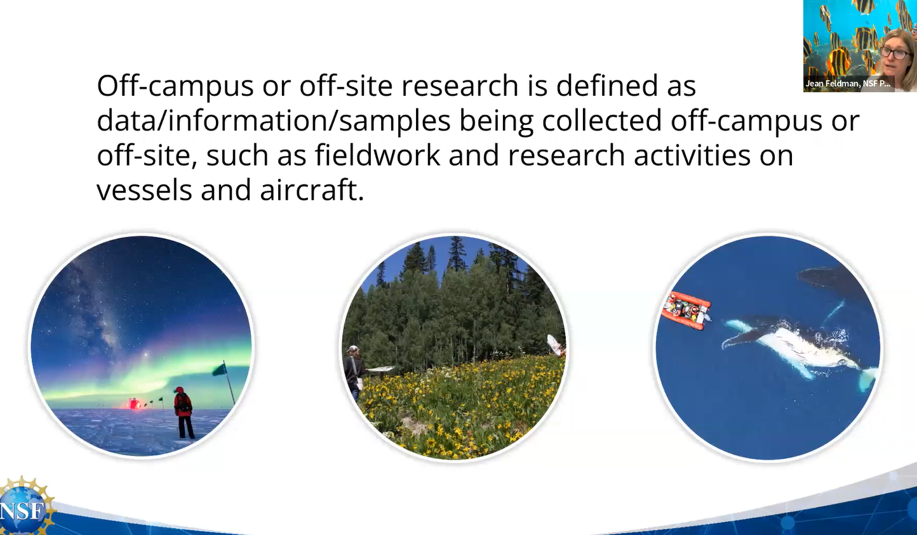

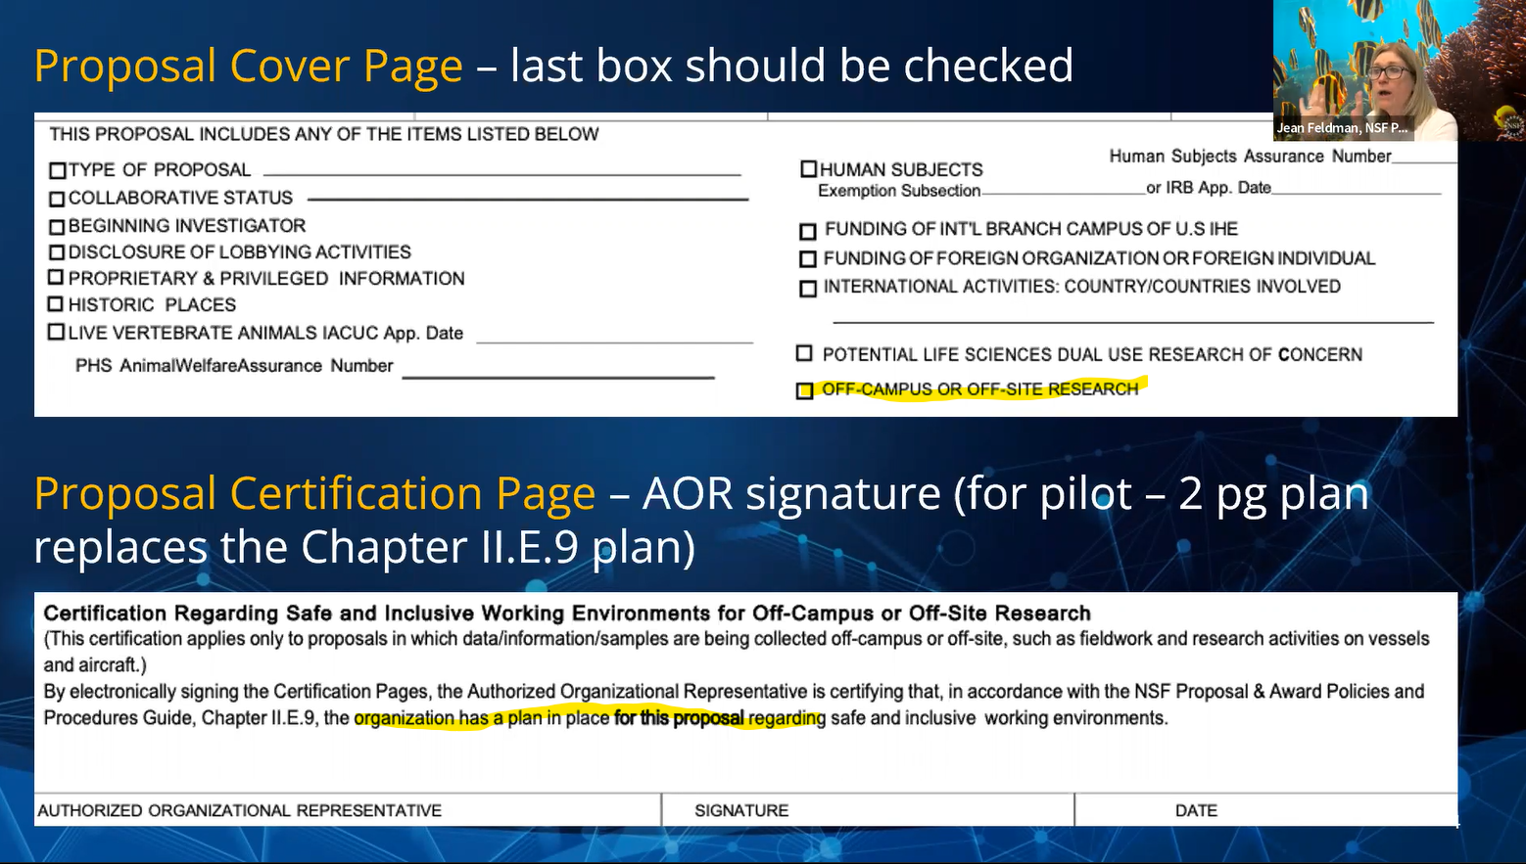
If proposal is in the NSF: GEO and BIO directorate (a pilot in 2023) MUST submit a 2 page supplemental document in lieu of certification

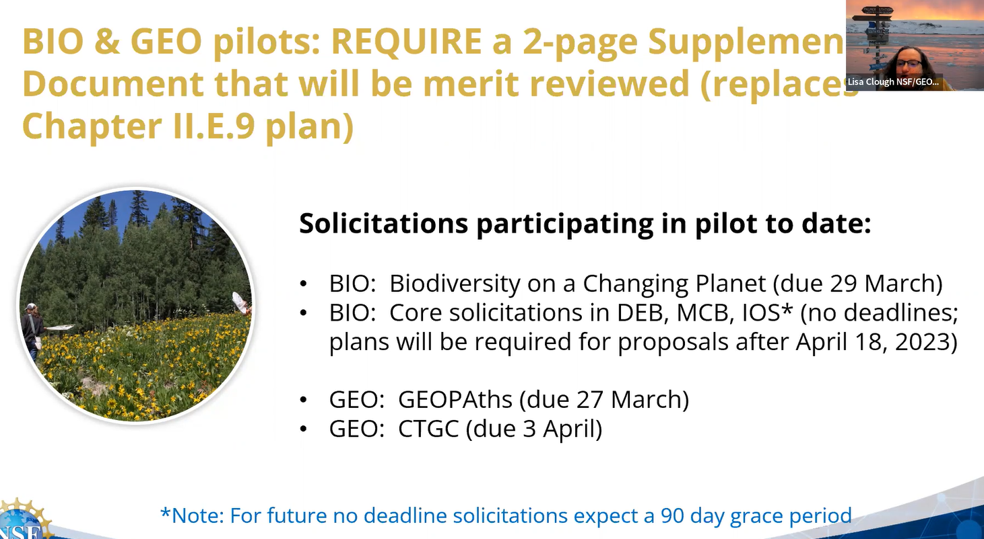
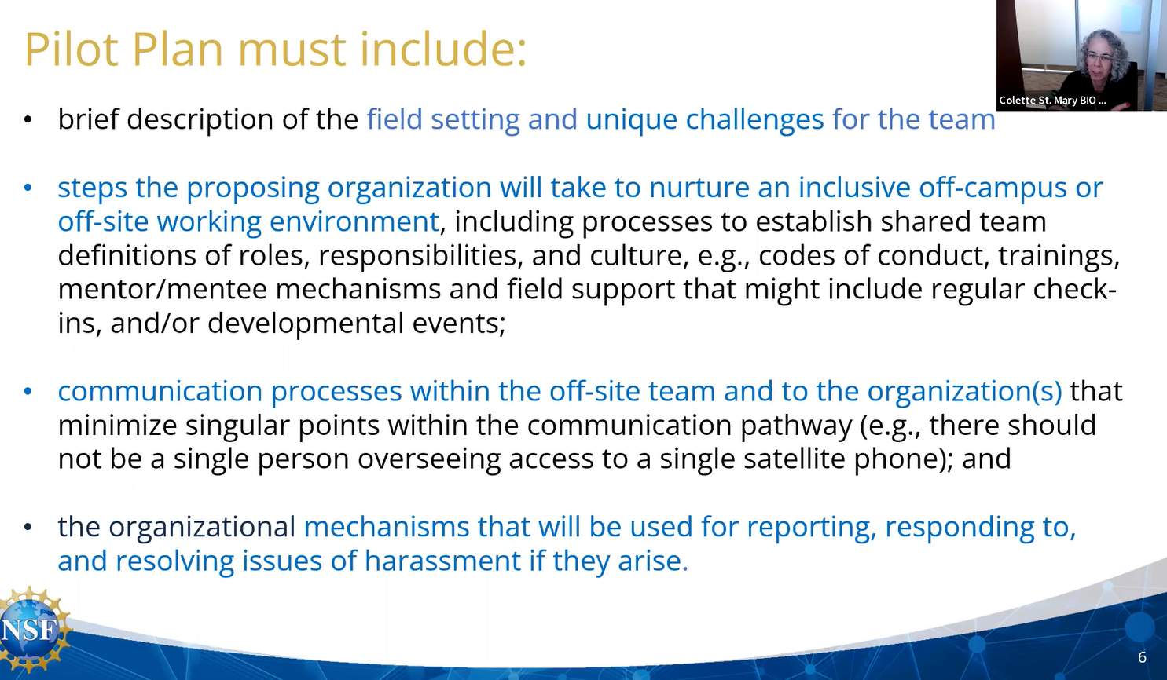
Whole document tailored to the specific proposal.

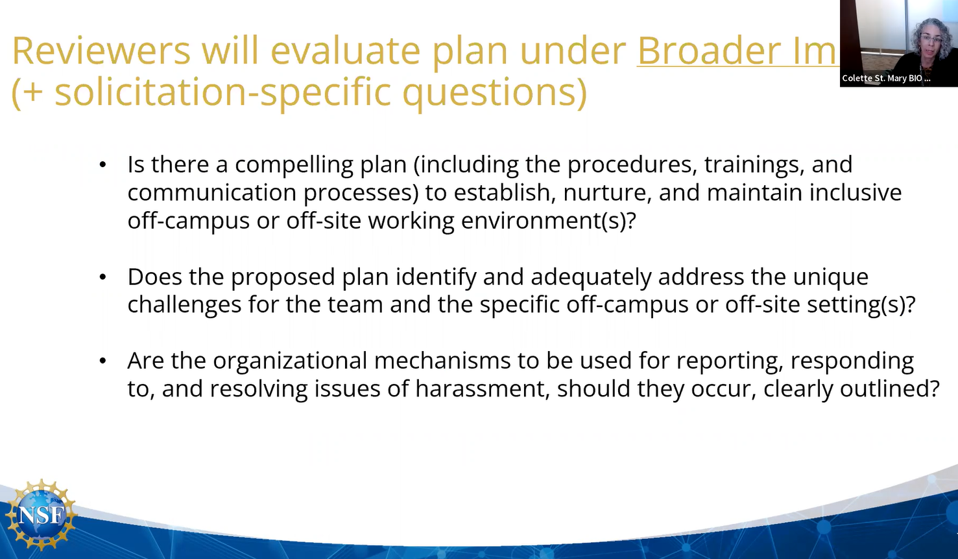
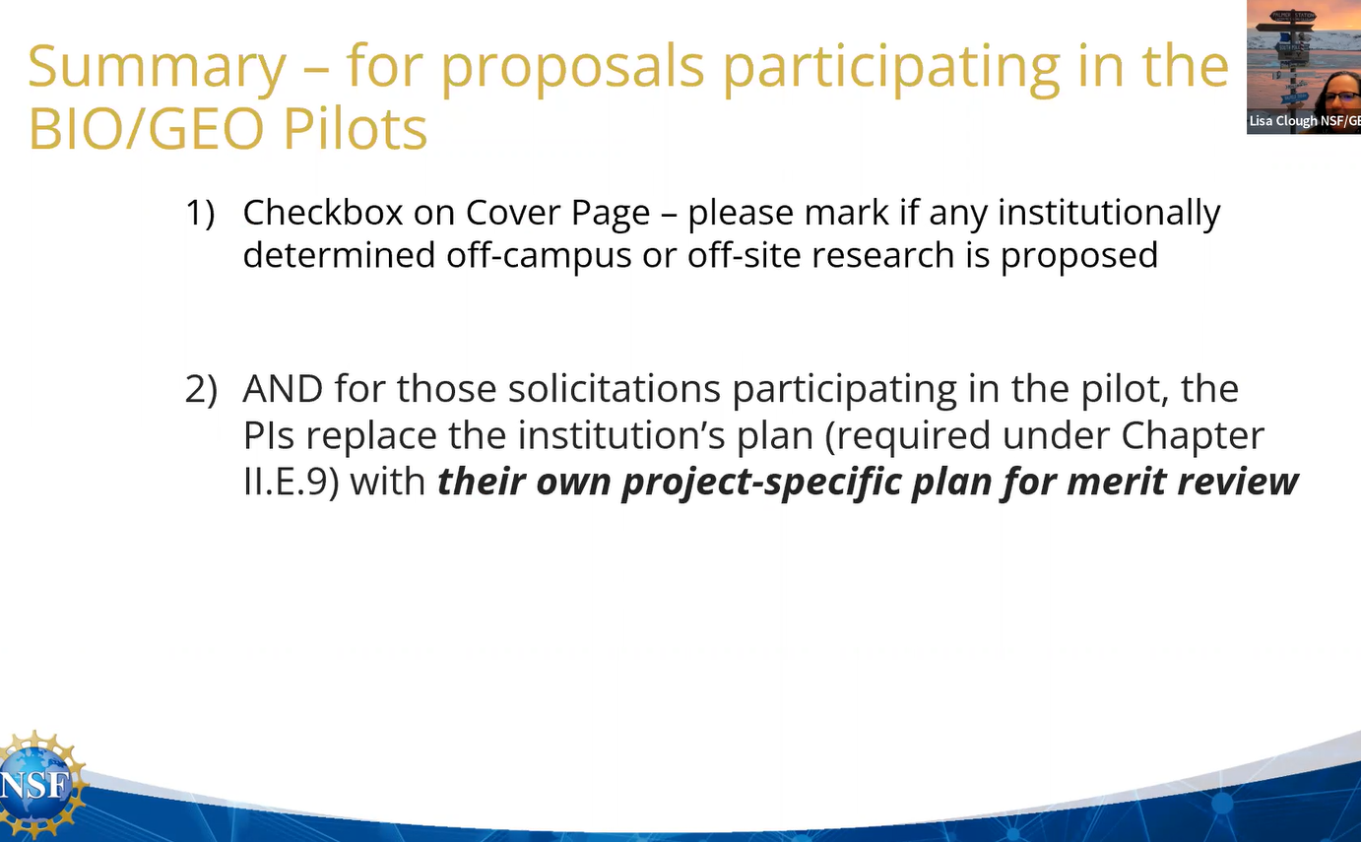
The academic institution (Sponsored Projects Office) determines what is off-campus or off-site research.
Subaward and Collaborative orgs will rely on the lead to check box and submit plan (even though they may see it on their end)

Applies to predominately RESEARCH for now, not EDUCATION proposals. Read the solicitation guiding each proposal.
National Labs? If educational institution views the location as “on-site” (safe and inclusive) then ok to NOT include a plan.
AOR does provide a certification as part of ALL the certifications when submitted electronically for the whole proposal. Accurate, current, and complete.
One Plan per proposal (meld a single plan if multiple organizations).
ONLY 2 pages allowed - A tailored to the project (NOT generic institutional plan)
TBD – How to handle in annual report if harassment occurs.
FAQs are coming.

If Vendor or public is gathering project data off-site or off-campus – Ask your sponsored projects office (?)
NSF’s new PAPPG (Proposal & Award Policies & Procedures Guide), effective for proposals with off-campus or off-site work due on or after January 30, 2023, requires proposers to certify that they have a plan for creating and maintaining Safe and Inclusive Working Environments for Off-Campus and Off-Site Research for that project.
NSF recognizes that a community effort is essential to eliminate sexual and other forms of harassment in science and to build inclusive scientific climates where people can learn, grow, and thrive. BYU’s Honor Code supports these goals.
For any offsite or field work on a proposed NSF project, the administrative home (school/college/institute/center) must attest there is a plan in place for that proposal. The plan must describe how the following types of behavior will be addressed:
- Abuse of any person, including, but not limited to, harassment, stalking, bullying, or hazing of any kind, whether the behavior is carried out verbally, physically, electronically, or in written form; or
- Conduct that is unwelcome, offensive, indecent, obscene, or disorderly;
For items 1 and 2 we recommend you reference the U-M SPG on Discrimination and Harassment (SPG 201.89-1) and Safety, Health and Environmental Policy (SPG 605.01).
The plan must also:
- Identify steps the proposing principal investigator(s)/project team will take to nurture an inclusive off-campus or off-site working environment;
- Consider how communications within the team and to the organization will be handled, minimizing singular points within the communications pathway (e.g., a single person overseeing access to a single satellite phone);
- Address how any special circumstances such as the involvement of multiple organizations or the presence of third parties in the working environment should be taken into account;
- Account for the process or method for making incident reports as well as how any reports received will be resolved.
The PI and project team should not submit the plan to NSF for review in the proposal, but they must have it in place prior to submission. The Office of Research and Sponsored Projects (ORSP) and the ITS eResearch team will provide details regarding changes in eRPM in forthcoming issues of The RAP and on the ORSP website.

This 2-page supplementary document must address the following four sections:
- a brief description of the field setting and unique challenges for the team;
- the steps the proposing organization will take to nurture an inclusive off-campus or off-site working environment, including processes to establish shared team definitions of roles, responsibilities, and culture, e.g., codes of conduct, trainings, mentor/mentee mechanisms and field support that might include regular check-ins, and/or developmental events;
- communication processes within the off-site team and to the organization(s) that minimize singular points within the communication pathway (e.g., there should not be a single person overseeing access to a single satellite phone); and
- the organizational mechanisms that will be used for reporting, responding to, and resolving issues of harassment if they arise.

BYU Policies

https://policy.byu.edu/view/campus-crime-awareness-prevention-and-reporting-policy
https://policy.byu.edu/view/church-educational-system-honor-code
https://policy.byu.edu/view/drug-free-school-policy
https://policy.byu.edu/view/firearms-and-weapons-policy
https://policy.byu.edu/view/honor-code-investigation-and-administrative-review-process
https://policy.byu.edu/view/nondiscrimination-and-equal-opportunity-policy
https://policy.byu.edu/view/personnel-conduct-policy
https://policy.byu.edu/view/participation-in-travel-tours-and-non-academic-programs-policy
https://policy.byu.edu/view/sexual-harassment-grievance-procedures-non-title-ix-sexual-violence
https://policy.byu.edu/view/sexual-harassment-grievance-procedures-title-ix
https://policy.byu.edu/view/sexual-harassment-policy
https://policy.byu.edu/view/minor-protection-policy
https://policy.byu.edu/view/sex-offender-policy
https://policy.byu.edu/view/travel-policy

